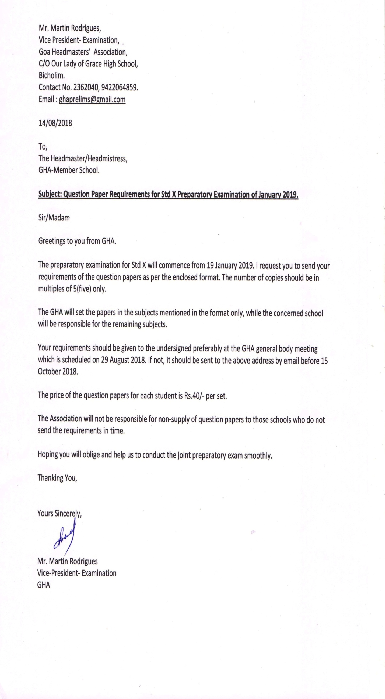
GOA HEADMASTER’S ASSOCIATION
Request for Question Papers
SCHOOL Index No: ___________
From:
Name of the Head: _______________
School: ______________
Ph.no. _______________
Mobile: ______________
E-mail: _______________

To,
The Vice- President- Examinations,
GHA.

Sir,
We wish to participate in the Joint Preparatory Examination of January 2019 to be conducted by GHA
Our requirement of question papers is as follows:-
For English Medium
Subject | No. of Papers
English( F.L.)
Hindi (S.L.)
Konkani (T.L.)
Marathi (T.L)
Urdu (T.L.)
Sanskrit (T.L)
Portuguese (T.L)
French (T.L)
Maths
Science
Social Science

We undertake to collect the papers as per this requisition form after doing the payments from the concerned centre.
We agree to abide by the directives of the association for smooth conduct of examination.
Yours sincerely,

Headmaster / Headmistress

